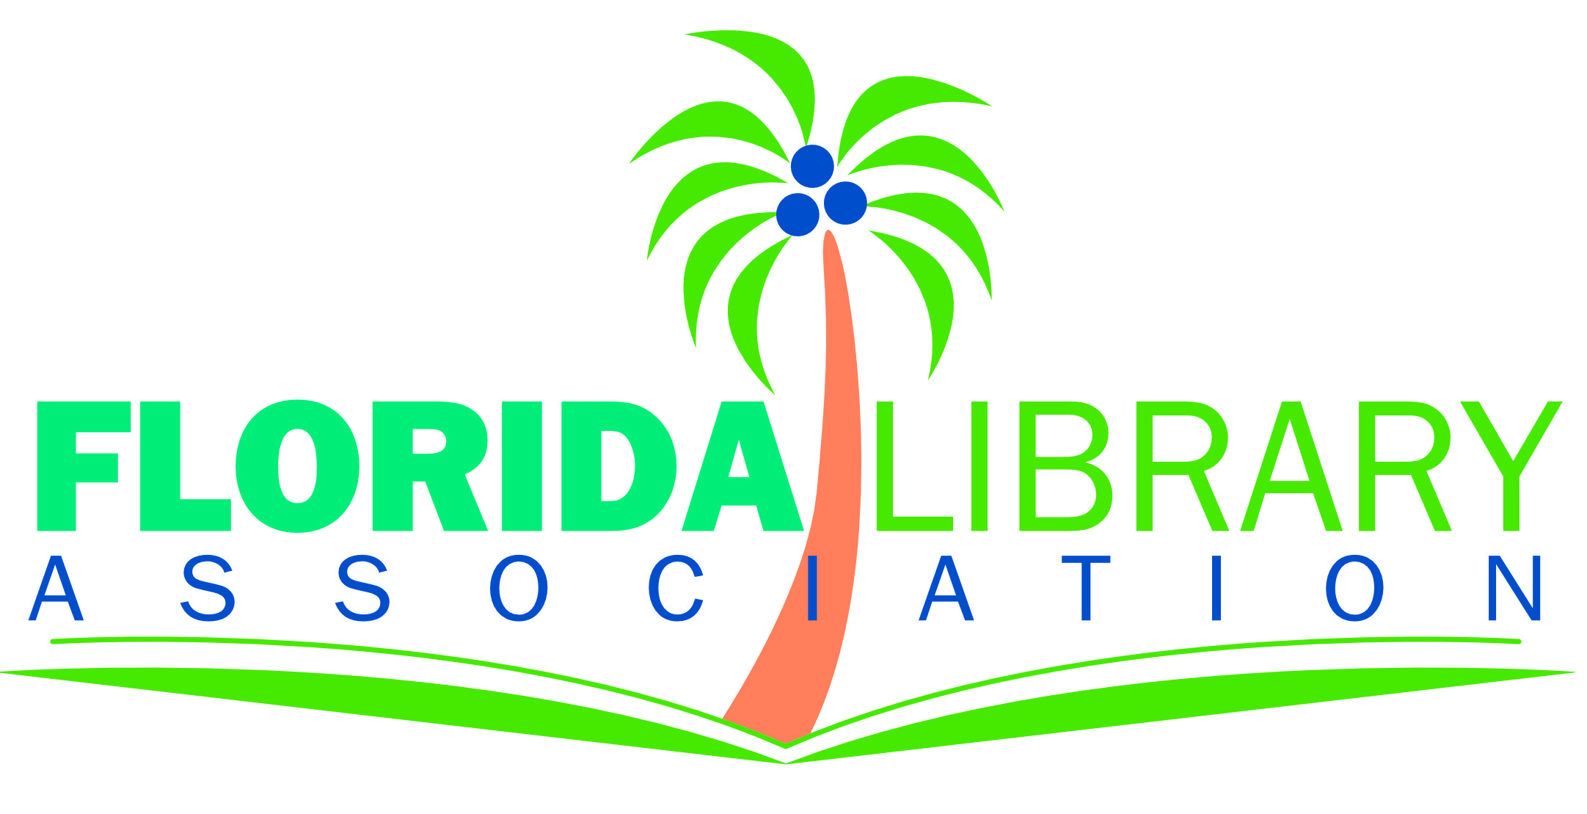

Florida House & Senate 2021 & 22 Leadership
Public Library Appropriations Subcommittees & Counties Their Members Represent
Senate
Senate President – Wilton Simpson (r) - Citrus, Hernando, & part of Polk - (President Designate 2022-24 - Kathleen Passidomo (r) – Collier, Hendry & part of Lee)
Full Appropriations Chair – Kelli Stargell (r) – parts of Polk & Lake
Senate Transportation, Tourism, and Economic Development Appropriations Subcommittee
- Chair – George B. Gainer (r) - Bay, Holmes Jackson, Walton, Washington & part of Okaloosa
- Vice-Chair Ed Hooper (r) – parts of Pasco & Pinellas
- Loranne Ausley (d) – Calhoun, Franklin, Gadsden, Gulf, Hamilton, Jefferson, Leon, Liberty, Madison, Taylor & Wakulla
- Jim Boyd (r) – Manatee & part of Hillsborough
- Janet Cruz (d) – part of Hillsborough
- Ileana Garcia (r) – parts of Miami-Dade
- Audrey Gibson (d) – part of Duval
- Debbie Mayfield (r) – Indian River & part of Duval
- Keith Perry (r) - Alachua, Putnam & part of Marion
- Annette Taddeo – (d) - part of Miami-Dade
- Tom Wright (r) – parts of Brevard & Volusia House of Representatives
House Speaker – Chris Sprowls (r) – part of Pinellas - (Speaker Designate - Paul Renner (r) 2020-2022 - Flagler & parts of St. Johns & Volusia)
Full Appropriations Chair – Jay Trumbull (r) – part of Bay
House Infrastructure and Tourism Appropriations Subcommittee
- Chair - Jayer Williamson (r) - parts of Okaloosa & Santa Rosa
- Vice-Chair – Bob Rommel (r) – part of Collier
- Kristen Aston Arrington (d) – part of Osceola
- Melony M. Bell (r) – DeSoto, Hardee & part of Polk
- Joseph "Joe" A. Casello (r) – part of Palm Beach
- Linda Chaney (r) – part of Pinellas
- Dan Daley (d) – part of Broward
- Brad Drake (r) – Holmes, Jackson, Walton, Washington, & part of Bay
- Dianne "Ms Dee" Hart (d) – part of Hillsborough
- Chip LaMarca (r) – part of Broward
- Fiona McFarland (r) - part of Sarasota
- James "Jim" Vernon Mooney, Jr. (r) – Monroe & part of Miami-Dade
- Jenna Dianne Persons (r) – part of Lee
- Rene "Coach P" Plasenca (r) – parts of Brevard & Orange
- David Silvers (d) – part of Palm Beach

