2021 FLA Program Proposal Practice Form
DO NOT SEND THIS VERSION TO FLA.
To be used as a guide to help you with the official form.

Email Address:

First Name:

Last Name:

Job Title:

Library / Organization Name:

Library/Organization Type:

Address Line 1:

Address Line 2:

City:

State:

Zip Code:

Work Phone:

Alternate Phone:

- Program length
- 60 minutes
- 90 minutes

- Program title:

- Program description (3500 characters maximum / approximately 500 words). To ensure fairness in the decision-making process, we use a blind peer review. This keeps the identity of the applicant anonymous. Please do not include your name, your library name or any identifying information in the abstract. If your name is in the abstract the proposal may not be accepted. All other identifying information you provided will be hidden from the reviewing committee:

- Learning outcomes. Provide 1-3 learning outcomes or takeaways that attendees will have after attending your session
- Learning outcome:
- Learning outcome:
- Learning outcome:

- This program would be of primary interest to librarians in the areas(choose 1):
- Administration and Management
- Adult Programming or Services
- Assessment
- Children's Programming or Services
- Collection Management
- Diversity
- Information Literacy
- Leadership
- Personal or Professional Development
- Reference Services
- Scholarly Communication and Publishing
- Special Collections and Digitization
- Technical Services
- Technology
- Tween, Teen or Young Adult Programming or Services
- Other

- Who is the primary audience for this program (choose up to 3):
- Academic Librarians
- General Librarianship
- Public Librarians
- Friends
- Retirees
- Research
- School Librarians
- Special Librarians
- Youth Services
- Other

- This program is aimed at audiences with the following level of expertise.
- Advanced (aimed at experienced professionals, covers leadership topics or supports a deep understanding of professional knowledge)
- Intermediate (aimed at mid-career professionals or managers. Knowledge learned would be beneficial to sharing with colleagues and subordinate staff)
- Beginner (aimed at entry-level professionals, is general to everyone, ordinary library work. Supports necessary job knowledge or enhances individual skills)

Room Set-up and Equipment:
Social distancing will most likely change the room set-ups. We will know more as we get closer to the event.
There are 3 types of room set-ups for breakout sessions. Choose the layout that best fits your needs and FLA will try to accommodate, however, there are no guarantees we can fulfill your request.
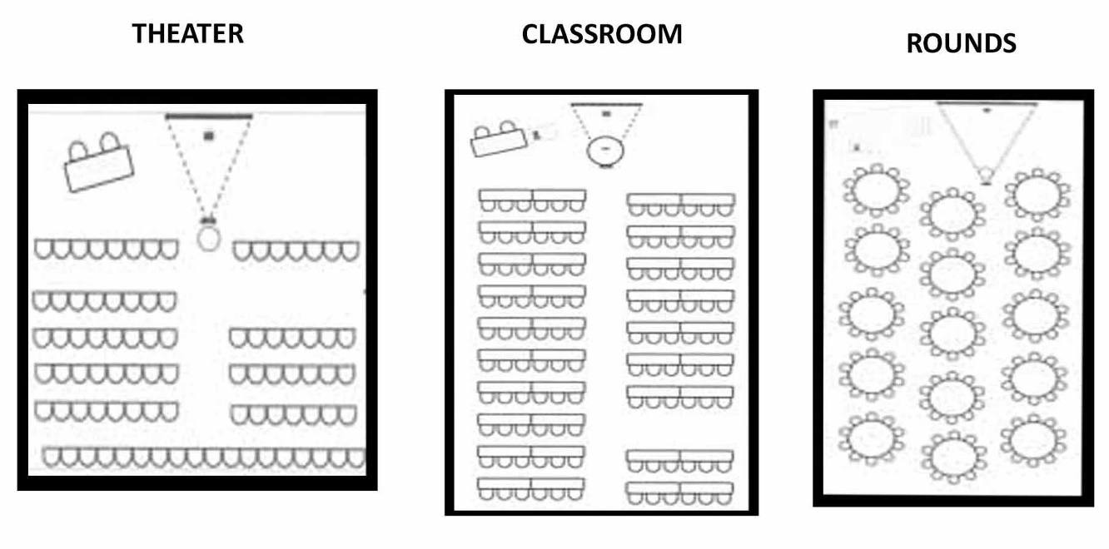
Standard Equipment Provided: LCD projector, screen, wireless internet, and a microphone at podium for larger sessions. No other equipment will be provided. No Laptops Provided. Program organizers are responsible for arranging for a laptop computer if one is needed. Note: Mac/Apple users must also provide their own cable to connect to the LCD projector.
- Breakout Session Room Set-up Request
- Theater
- Classroom
- Rounds

- Where and when has this program been presented? Leave blank if this question does not apply.

- FLA Committee or Member Group sponsoring the program (if applicable)

- List each speaker for this program and provide full contact information for each. Space is available to list up to four speakers. If your program will have more than four speakers, contact. FLA Membership and Events Manager Karen Layton, karen@flalib.org.

Speaker 1: Provide full name, organization, email address and phone number

Speaker 2: Provide full name, organization, email address and phone number

Speaker 3: Provide full name, organization, email address and phone number

Speaker 4: Provide full name, organization, email address and phone number

- Will the Program Organizer introduce the program speakers and moderate this program?
- Yes
- No

- Is the Program Organizer a speaker?
- Yes
- No

- Scheduling Preferences. Please provide if applicable the dates and times the program should not be scheduled and Conference events or programs which this program should not be scheduled opposite. Every effort will be made to accommodate preferences but cannot be guaranteed.

To fill out the official 2021 Conference Proposal Form, please go to:
https://fla.memberclicks.net/2021-fla-call-for-breakout-session-proposals

